Task 5 Report

Implementation
While the thought process behind the multistep, multivariate problem proved to be complex, the final implementation requires very little change to the code. Initially I attempted simply changing the lookup_steps to the days requested in the future (‘k_days’) but of course this only returns one day of predicted data rather than an ongoing series of predictions. Next I attempted using a 2D for loop to add an extra column to the dataframe containing all the future values between the lookup_steps ahead and the k_days on top of that. For every row in the dataframe, then for every row between i+lookup_steps and i+lookup_steps+k_days take the ‘Adj Close’ value and add it to ‘somewhere’. Ultimately I realized the output data doesn’t need to be coupled to the dataframe so I just made it it’s own 2D array of values; A list of future values for every date currently provided.
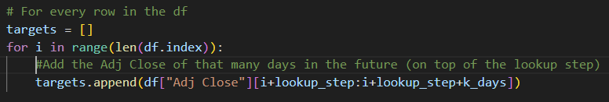
Next I appended these target values in the sequences. Since the values aren’t directly linked via the date index I just used an incrementing pointer. Logically the dataframe rows and target rows should be directly correlated even if not coupled in the code.
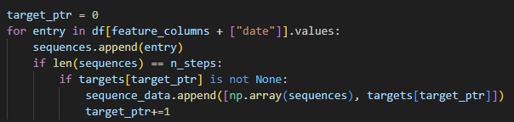

Finally, I changed the model so that the output layers contains k cells, rather than the 1 prediction cell.
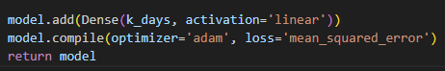

Multivariant Solution
Thankfully the solution to the multivariant problem was already included in previous tasks. We can adapt the feature columns variable to include however many features we like in the input to the model. The main difference in this inclusion, compared to the original solution of only taking the ‘Close’ column, is assuring that each selected column is properly normalized and included as a part of the sequence data. Attached are some examples where this is taken into account.
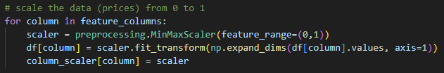
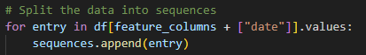

Output
Although not perfect, the prediction clearly shows a precise correlation to the actual values. Here was the output from 100 days of prediction.
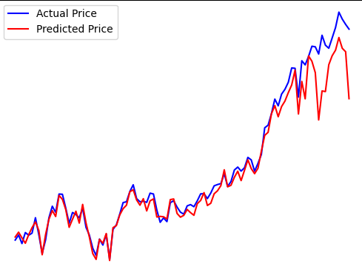
Interesting to note that the further into the future, the more volatile the prediction. Of course this is to be expected and if anything helps to solidify that the model is indeed working off its own predictions rather than simply copying and altering the actual data.

